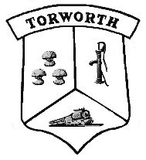
AGENDA FOR THE TORWORTH PARISH COUNCIL MEETING TO BE HELD AT TORWORTH GRANGE FARM SHOP AND CAFÉ, TORWORTH.

TUESDAY May 7th, 2018 AT 7:00PM

Open Forum for members of the public to attend.

- Members of the public

- Welcome & Apologies

- Declaration of Interest

- Crime Report

- County and District Councillor Reports
- T. Taylor and M.Gray to update

- Minutes of the previous meeting:
- A review of the previous minutes
- To be signed as a true and accurate record by the Chair person.

- Matters Arising.
- Allotments

- Finance
- Payments for approval, including Debit card transactions
- Bank Reconciliation
- Adoption of the Finance Policy

- Amenities and Facilities:

- Planning Issues declared before or at the meeting:
- The new Draft Mineral plan
- Housing development on The Great North Road

- Correspondence

- Updates from Other Committees and Forums

- Information to forwarded to the next meeting & AOB

- Date of the next meeting: Tuesday June 4th, 2019 at Torworth Grange Café at 7pm.

All members of the public are welcome to attend.
For all queries please contact: parishcouncil@torworth.org.uk or a member of the Parish Council direct.

